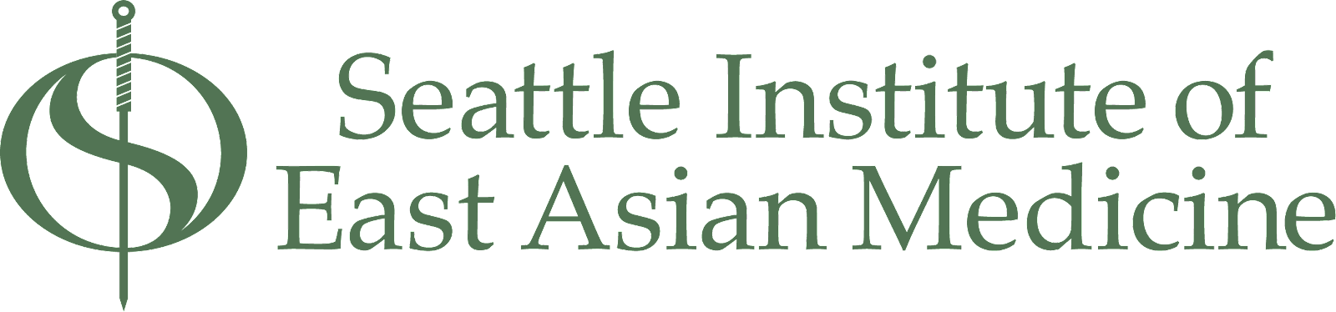

6363 7th ave S | Seattle, WA 98108 | (206) 517-4541 | www.sieam.edu

Admissions
All students interested in the Master of Acupuncture and East Asian Medicine degree (M.Ac.E.A.M.), and the Doctor of Acupuncture and Herbal Medicine (D.A.H.M.) must meet the following admissions requirements and procedures. Please read carefully.

General Admissions Requirements
Applicants to SIEAM must have at least three years of college study at the baccalaureate level (90 semester or 135 quarter credits) with a minimum 3.0 G.P.A. These credits are to include the following topics that provide training in the basic sciences appropriate for the health care field.

- Biology (no lab required)
- Chemistry (no lab required)
- Psychology (no lab required)
- Western Nutrition (no lab required)

NOTE: Applicants who have not completed all prerequisite coursework may still apply. If accepted, enrollment would be contingent upon completion of all prerequisites prior to the first day of fall classes with a B average or above.

All applicants must have up-to-date basic CPR/AED training and First Aid certification prior to starting the program. Standard Red Cross certifications are sufficient for this requirement.

Candidates for admission must demonstrate maturity, academic ability, and sincerity to enter the field of East Asian medicine.

English Language Requirement
All classes are taught in English. Therefore English language competency is required of all students seeking admission to the program. International applicants whose native language is not English are required to provide proof of English proficiency for admission to degree, certificate, and non-degree graduate programs. This must be demonstrated by one of the following means:
1. The applicant must have completed one of the following:
a) four years at a U.S. high school demonstrably delivered in English;
b) at least two-years (60 semester credits or 90 quarter credits) of undergraduate- or graduate-level education in an institution accredited by an agency recognized by the U.S. Secretary of Education;
c) at least two-years (60 semester credits or 90 quarter credits) of undergraduate- or graduate-level education demonstrably delivered in English;
d) high school or two-years (60 semester credits or 90 quarter credits) of undergraduate- or graduate-level education in an institution in one of the following countries or territories: American Samoa; Anguilla; Antigua & Barbuda; Australia; Bahamas; Barbados; Belize; Bermuda; Botswana; British Virgin Islands; Cameroon; Canada (except Quebec); Cayman Islands; Christmas Island; Cook Islands; Dominica; Federated States of Micronesia; Fiji; The Gambia; Ghana; Gibraltar; Grenada; Guam; Guyana; Ireland; Isle of Man; Jamaica; Kenya; Lesotho; Liberia; Malawi; Montserrat; Namibia; New Zealand; Nigeria; Norfolk Island; Papua New Guinea; Philippines; Pitcairn Islands; Sierra Leone; Singapore; South Africa; South Sudan; St. Helena; St. Kitts & Nevis; St. Lucia; St. Vincent & the Grenadines; Swaziland; Tanzania; Trinidad and Tobago; Turks and Caicos Islands; United Kingdom; U.S. Virgin Islands; Uganda; Zambia;
In all cases, English must have been both the language of instruction and the language of the curriculum used.
OR
2. The applicant must have completed one of the following assessments at the required level:

ASSESSMENT TOOL | ACCEPTABLE  SCORE
Test of English as a Foreign Language Internet-Based Test (TOEFL® iBT) | Total: 61
International English Language Testing System (IELTS), Academic Format | Overall band: 6
Duolingo English Test | 90
China Standard of English Language (CSE) | CSE 6
Cambridge First Certificate in English (FCE) | C
Cambridge English Advanced (CAE) | C
Common European Framework Reference (CEFR) | B2
Occupational English Test (OET) | 250, C
Pearson Test of English (PTE), Academic | Overall: 45

Application for Admission

Required Materials:
- Completed SIEAM application. The application is online at: www.sieam.edu/admissions.
- The application asks you to address the following topics:
  - Essay describing your reasons for choosing this field and the Seattle Institute.
  - A brief explanation of how you plan to finance your education and living expenses
- Transcripts from all prior higher education institutions.
- Transcripts from other countries must be translated into English and evaluated by a credential-evaluation service. We suggest World Education Service (www.wes.org)
- $100 non-refundable application fee
- Signed Prospective Student Release of Information form
Note: Applications will not be reviewed by the Admissions Committee until all the elements listed above are present.

Admissions Process
SIEAM accepts applications beginning in September for entry into the following September’s program until the class is full. Since class size is limited, applicants are encouraged to apply as early as possible.
Applicants whose initial applications are approved will be invited to attend a required admissions interview. Interview spots are on a space-available basis. Dates will be posted on www.sieam.edu under the Admissions section. Prospective students should submit applications at least one month prior to the date they wish to interview. We recommend that out-of-state applicants who need additional time to make travel arrangements apply as early as possible.
Following the interview, applicants will receive a decision on acceptance within two weeks. Accepted applicants will then have two weeks to submit their enrollment agreement and nonrefundable $500 deposit to reserve their place in the entering class. This deposit will be applied to the first trimester’s tuition. Some applicants may be placed on a wait list.

Admissions Policies

Transfer Credit to SIEAM:
There are provisions for students to transfer credit for previous biomedical science courses. Assessment of transfer credit is done on a case- by-case basis. SIEAM does not accept transfer credit for any East Asian medicine training done at other institutions.
To receive transfer credit, students submit a Transfer Credit Request Form and provide records of previous college credit. It may also be necessary to submit additional documentation and/or take a competency exam in the material.
Acceptance of transfer credit does not affect the overall cost of the program or the length of time to complete the program.

Advanced Standing:
There is no advanced standing for the M.Ac.E.A.M. degrees. All accepted students start at the beginning of the program.

Deferral of Entrance into a Program:
While it is possible to have permission granted for a one-year deferral, a deferral is only granted after the SIEAM administration has reviewed the written request and deemed it acceptable. Failure to remain in contact with school administration during the deferral year may result in the program acceptance being withdrawn.

Questions? Contact us at admissions@sieam.edu

