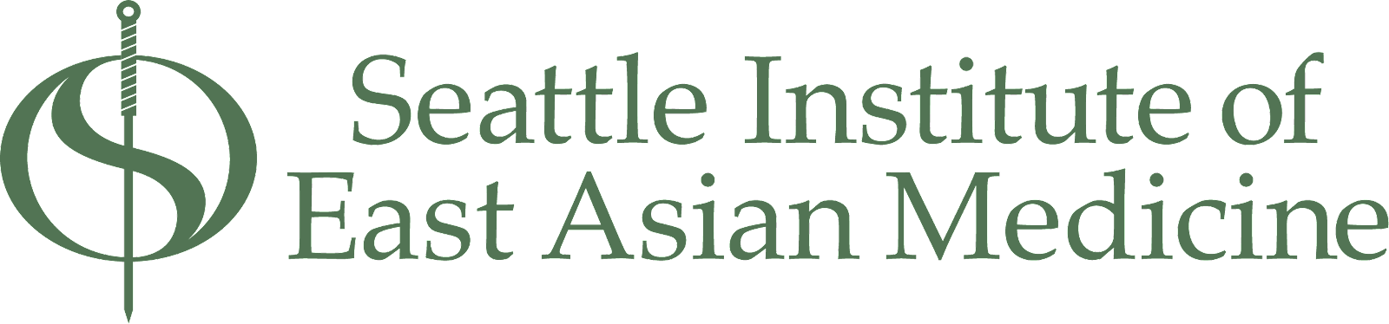

6363 7th ave S | Seattle, WA 98108 | (206) 517-4541 | www.sieam.edu

RETURN OF TITLE IV FUNDS
Tuition Refund: Students are entitled to a refund of tuition and fees based on the following schedule. If you withdraw before the end of the:
First week of class 100% (Except for the reservation fee for first trimester students)
Second week of class 90%
Third week of class 80%
Fourth week of class 70%
Fifth week of class 60%
Sixth week of class 50%
Eighth week of class 25%
After the eighth week No Refund
Withdrawals and Return of Title IV Funds:
In accordance with federal regulations, SIEAM will determine the amount of earned and unearned portions of Title IV aid as of the date a student withdraws or ceases attendance. This policy applies to all students receiving Title IV funds who do a complete withdrawal on or before earning 60% of the Title IV funds. The 60% date is the date by which a student has been enrolled for five weeks of the term. Students who withdraw after the 60% date will have earned all of the financial aid received for that term and are responsible for paying back all of the funding for that term. If the calculation determines that SIEAM is required to return funds, the funds are returned to the lender in the following order: Federal PLUS Loans, Federal Unsubsidized Loans.
Withdrawal Date: The official withdrawal date is the date when withdrawal occurs in any of the following ways:
- The Institute receives written notice of the student's intention to discontinue the training.
- The student is terminated for a violation of a published school policy that provides for dismissal.
- The student, without notice to the Institute, fails to attend classes for 30 calendar days with the withdrawal date being the last day of attendance.

